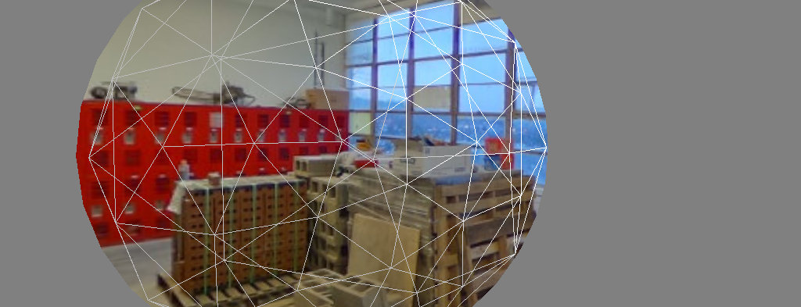

Lab 3: VR Video

Due: March 8

Problem 1:

If you have not already, finish implementing the video spheres that work by toggling the visibility of the world and the skybox.

Writeup:

Describe your process in sufficient detail that someone else could follow it. If you wrote code, include the code (linking to a github repo is a good way to do this). Indicate what references you used.

Problem 2:

In this part you will implement the panorama mapping with a shader rather than geometry. By creating an inside-out sphere with an appropriate shader, we can create a video sphere that can be entered without requiring any special javascript logic. The included shader uses an incorrect panorama mapping (an orthographic projection, to be precise)-- change the shader to implement the same equirectangular projection as in Lab 2.

Writeup:

Again, describe your workflow so that someone else could follow it.

**Include images of the shaded sphere,** both from outside and inside the sphere. If you correctly implemented the projection, then straight lines in the panorama should be straight regardless of camera location (see the header image as an example: the viewpoint is outside the sphere, yet the lines are straight).

Problem 3:

TBD